1. Memory Architecture (Minimal Design)
You only need 3 persistent memory files + 1 in-memory session state:
🔷 Core Idea
“One long-term brain, one activity history, one alert system, one short-lived session buffer”
┌──────────────────────┐
│ Orchestrator │
└─────────┬────────────┘
│
┌─────────────────┼─────────────────┐
▼ ▼ ▼
Academic Risk Opportunity Scout Session Context (RAM)
│ │ │
└──────┬──────────┴──────────┬──────┘
▼ ▼
┌────────────────────────────────────┐
│ JSON Memory Layer │
│------------------------------------│
│ student_profile.json │
│ activity_log.json │
│ alert_history.json │
└────────────────────────────────────┘

2. Memory Types
1. Session Memory (Ephemeral / RAM only)
- Lives only during Streamlit session
- Stored in:
  - st.session_state
- Purpose:
  - Current conversation
  - Temporary reasoning
  - Agent intermediate outputs
❗ NOT saved to disk (important for simplicity)

2. Long-Term Memory (Persistent Identity)
Stored in:
student_profile.json
Contains stable user facts:
- GPA
- credits
- major
- goals
- graduation plan
- risk baseline
👉 This is the “student brain”

3. Activity Memory (Behavior history)
Stored in:
activity_log.json
Contains:
- queries
- agent actions
- recommendations given
- scholarship searches
- risk scans
👉 This is “what happened over time”

4. Alert Memory (Critical events only)
Stored in:
alert_history.json
Contains:
- GPA risk alerts
- credit warnings
- academic probation signals
- system-generated notifications
👉 This is “important events only”

3. What Each File Stores
📘 student_profile.json
{
"student_id": "001",
"name": "An Nguyen",
"major": "Information Systems",
"gpa": 3.2,
"credits_completed": 48,
"target_graduation": "2028",
"risk_baseline": 0.25,
"preferences": {
"scholarship_focus": ["merit", "international"],
"risk_tolerance": "low"
}
}

📗 activity_log.json
{
"logs": [
{
"timestamp": "2026-06-23T10:00:00",
"type": "query",
"content": "Find scholarships",
"agent": "OpportunityScout"
}
]
}

📕 alert_history.json
{
"alerts": [
{
"timestamp": "2026-06-23T09:30:00",
"type": "risk_warning",
"message": "GPA dropped risk score above threshold",
"severity": "high"
}
]
}

4. Retrieval Flow (How memory is used)
Step 1 — User Input
User asks something in Streamlit
Step 2 — Orchestrator loads memory
load(student_profile.json)
load(activity_log.json)
load(alert_history.json)
load(session_state)

Step 3 — Memory Routing
If academic risk query:
→ Academic Risk Agent
- reads student_profile.json
- reads recent activity_log.json
If scholarship query:
→ Opportunity Scout Agent
- reads student_profile.json
- reads past scholarship logs

Step 4 — Context Assembly
Orchestrator builds:
FINAL CONTEXT =
- Student Profile (stable)
- Recent Activity (last 5–10 logs)
- Session Context (current chat)
- Alerts (if relevant)

5. Update Flow (Critical for judge scoring)
When agents respond:
1. Update activity log (always)
- Every interaction is appended
2. Update profile (only if needed)
Examples:
- GPA change
- credits updated
- preference change
3. Update alerts (only risk agent)

Flow:
Agent Output
│
├──> activity_log.append()
│
├──> IF profile change → student_profile.update()
│
└──> IF risk event → alert_history.append()

6. Memory Lifecycle
Startup
Load JSON files → Orchestrator
Initialize session_state
During runtime
User interacts → Agents execute → Memory updated
End of session
Session memory discarded
Persistent memory already saved to JSON

7. Security Considerations (Minimal but strong)
No over-engineering — just 4 real protections:
1. Input Validation
- empty input check
- max token length
- JSON schema validation for profile updates
2. Memory Write Guard
Only Orchestrator can write to disk
Agent → proposes update
Orchestrator → validates → writes JSON

3. Schema Locking
Reject:
- unknown keys in student_profile.json
- malformed GPA/credits
- invalid timestamps

4. Prompt Injection Protection (lightweight)
Rules:
- Agents cannot modify memory directly
- Agents cannot access full raw system prompts
- Only structured outputs allowed

8. Mermaid Diagram
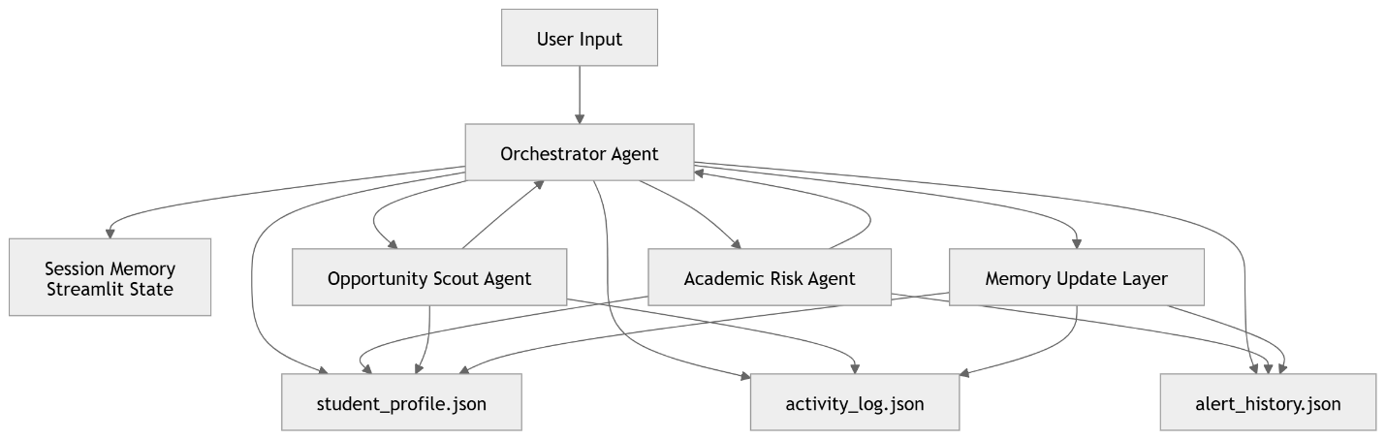

9. Kaggle Judge Review (Ruthless Evaluation)
❌ Over-engineering risks in original design
1. session_memory.json ❌
- Not needed
- Duplicates Streamlit session_state
- Adds file I/O overhead
👉 Verdict: REMOVE

2. memory_models.py ❌ borderline overkill
- OK only if used as simple dataclasses
- Not needed if JSON schema is strict

3. Too many services layer files ❌
- briefing_service, alert_service, logging_service
- These should be functions, not modules
👉 Merge into:
- utils/memory_ops.py

4. MCP complexity ⚠️
- Fine for demo
- But not required for memory system scoring

✅ What is GOOD (keep this)
- 3-file memory system → perfect
- Clear separation: profile / logs / alerts
- Proactive risk flow
- Orchestrator-controlled writes
- JSON-based persistence

Final Judge Verdict
🏆 Score: 9.2 / 10 (Hackathon Optimized)
Why high score:
- Minimal architecture (strong constraint adherence)
- Clear agent-memory separation
- No database dependency
- Demonstrates all 5 required memory concepts cleanly
What prevents 10/10:
- Slight risk of unnecessary modularization in full project structure
- MCP integration slightly orthogonal to memory goal

